Cyara Tags and Descriptions:

**{AllowHangUpInReply}** : If the far end hangs up while a step is playing its reply, the step is normally flagged as a failure. However, if this tag is present in the “Expect To Hear” field, this situation will not be flagged as a failure.

**{AlphaNum}** : This tag is used to recognise spoken numbers or numerals in English.

**{BargeIn}** : This tag indicates that the reply should interrupt the prompt being heard after the time specified in the ‘PSST’ field. The ‘barge-in’ occurs after the specified time (in seconds) after the beginning of the audio for the step is detected.

**{BypassRecognition}** : The {BypassRecognition} tag is used to indicate that speech recognition should not be done on any of the audio heard in this step. This will return a false 100% positive result.

**{Choice}**: A Choice tag can be used when matching a prompt that has at least two known possibilities. The user can specify multiple phrases and the recognition engine will attempt to match the prompt against each phrase.

**Examples:**

Good morning, Welcome to {Choice Optum global solutions|United Health groups|United Health care}

**{Digits}**: The Digits tag recognizes a set of numbers pronounced individually. It is useful when a prompt pronounces telephone numbers or PIN.

**{Date}**: The {Date} is used to recognise a spoken date in a prompt.

**{EndCallIfNoAudioWithinThreshold}** : Use this tag to specify that the call should be ended if no audio is heard within the Major Threshold Time of the step. If this tag is used and the silence at the beginning of the step exceeds the threshold, the call is ended immediately with reason "Abandoning call because no audio was heard within n seconds"

**{Fax}** : The {Fax} tag indicates that a Fax tone is expected (specifically, a 2100 Hz fax CED tone) within the Major Threshold Time.

**{Ignore}** : This tag skips a part of the call flow. The period to ignore is specified in seconds in the PSST field and the period begins at the end of the previous step. The "Reply With" portion of the step (if specified) begins after the ignore period.

**{Insert}** :

This tag can be used in the 'Reply With' field insert certain variables to reply in a step.

Ex: {Insert CLI Separator="Test" Separator="Hi" Separator="Hello"}

{Insert CLI Suffix="13" Prefix="10" Separator="11"}

{Insert DNIS Default="100 100 1000" Separator="100 100 1001" Separator="100 100 1002"}

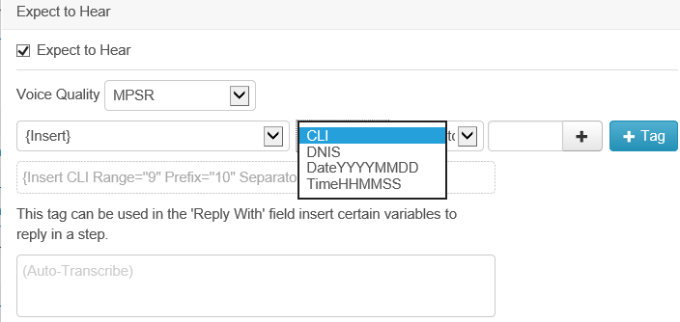

**{Language}** : The {Language} tag is used for speech that deviates from the default speech recognition language on a particular step.

**{MaxAudioLength}**: Use this tag to specify a maximum duration for the audio heard in this step (starting from the beginning of audio - i.e. skips any leading silence).

**{MeasureResponseTimeTo}** : The {MeasureResponseTimeTo x} tag causes step response time to be calculated from end of previous step to when audio or speech is heard.

{MeasureResponseTimeTo BeginningOfAudio}

{MeasureResponseTimeTo BeginningOfSpeech}

**{Number}** : The Number tag recognizes numbers spoken naturally instead of a sequence of individually pronounced digits.

**{Optional AudioLength}** : The {Optional AudioLength} tag is used to mark a step as “optional” for situations where prompts may/may not be played (e.g. high volume messaging, holiday messages, promotions). The length of the audio is used to determine whether the prompt has been played.

Ex: {Optional AudioLength=1-2} Test step for verifying the optional audio length

**{Optional Speech}** : The {Optional Speech} tag is used to mark a step as “optional” for situations where prompts may/may not be played (e.g. high volume messaging, holiday messages, promotions). Speech recognition is used to determine whether the prompt has been played.

**{Repeat}** : The {Repeat} tag is used to repeat a Test Step. The Test Step is repeated until the text does not match. A maximum repetition count may be specified.

Ex: {Repeat 3} – 3 represents the count of prompt that has to be repeated.

**{Sensitivity}:** The {Sensitivity} tag sets the sensitivity level of the voice detector. A value of 1.0 means that it is highly sensitive to quiet input. A value of 0.0 means it is least sensitive to noise. The default value is 0.5.

Ex: {Sensitivity 1} – 1 represents the sensitivity level

**{Time}** : The {Time} is used to recognise a spoken time in a prompt. The {Time} tag is very flexible and can be used to recognise many different time formats in the native language for the account. For example: 'At the third tone the time will be {Time} precisely.

**{WaitForHangup}:** This tag is used to indicate that the call should not be terminated by the Cyara Platform after the last step, but the Cyara Platform should wait for the called party to hang-up.

**{*}**: The wildcard tag can be used to ignore part(s) of a prompt in recognition. It can be used to match anything in the Expect to Hear prompt.

**Inbound/Outbound** : The type of Call Flow. Inbound dials out into the clients system. Outbound receives an incoming call from the clients system.

Campaigns :

Based on the plan “Pulse or Velocity or Outbound

Test Case Distribution Profile:

**Equal Probability:** Each Test Case has exact same probability of running

**Round Robin:** All Test Cases are executed in Round Robin fashion

**User Defined Probability:** Each Test Case has custom defined probability of running. Probabilities are set in the table below

**Conditional Next:** Test Cases are executed conditionally starting from top. Each subsequent Test Case will execute only if the previous one has Failed or been Satisfactory